In this take home problem, you will be asked to render synthetic images of a single object and train a CNN which will regress the **projected bounding box corners** of that object. **This project should be completed within a week of assignment, and should not require significant computational resources**. High performance of the network is not crucial to success, but the model should demonstrate reasonable results.

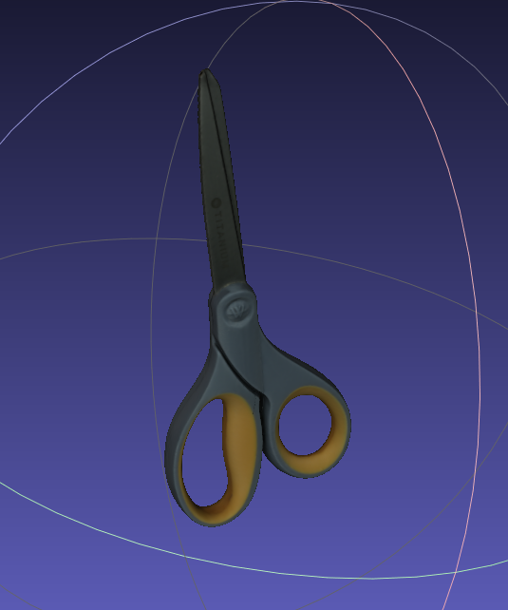

The object to be rendered can be found in the same folder as this document. The object should be placed between **10-15cm** in front of the camera using the provided intrinsic parameters which can also be found in the same folder.

For data generation, the object's pose should be randomized within 5 cm along all axes and freely along the rotation axes. I would recommend using [Open3d](http://www.open3d.org/docs/latest/python_example/visualization/index.html?highlight=render_to_image#render-to-image-py) for performing the rendering. Lighting, background, and texture should be kept consistent for all images in training and test sets.

Architecture selection is not crucial and pretrained networks can be used. Keep in mind that this should be a short project and that large models may take too long to train.

For the final deliverable, please provide:

* Figures showing loss on training and test sets.
* One or more metrics describing the performance of the model.
* The code used for generating the data and training the model.
* The images of the generated dataset used for training and evaluation.